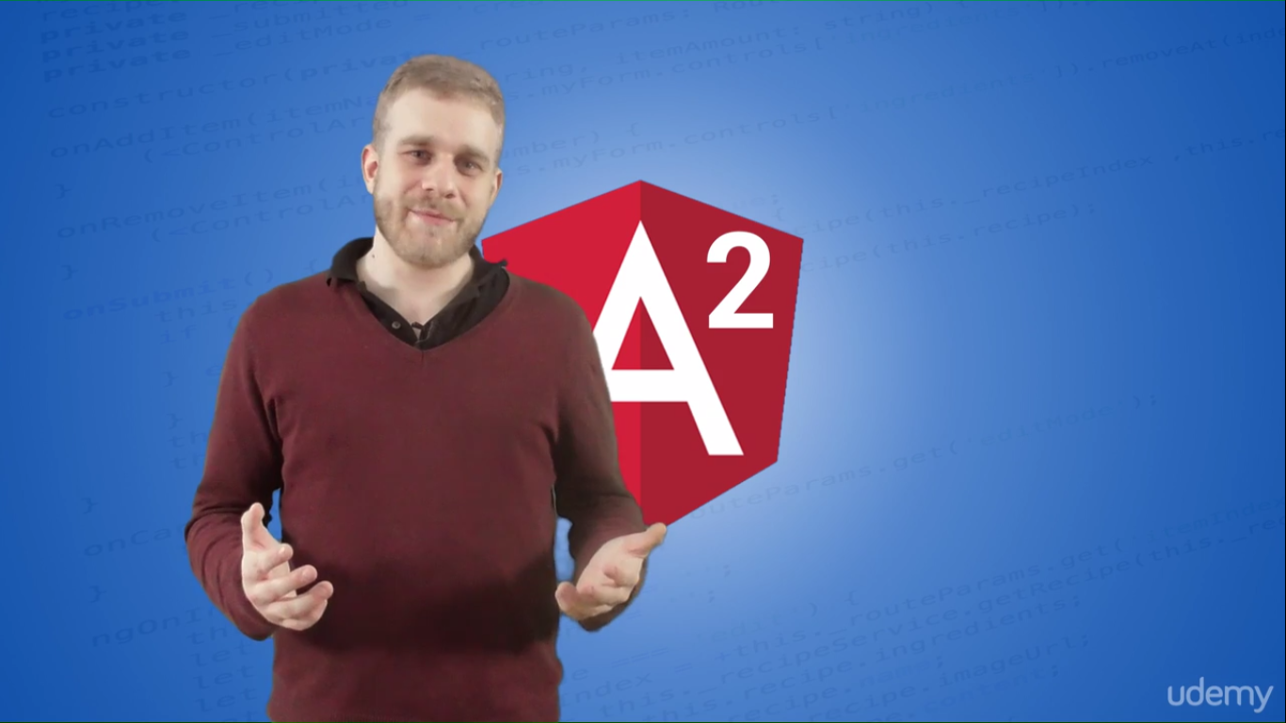

**What is Angular2:** It’s a Javascript framework that allows us to create SPA.

**SPA** offer a familiar feeling of apps on mobile phone as we are not constantly sending requests similar to a traditional MVC. So there is a single HTML and angular will constantly change the DOM and Request and Response are via AJAX and javascript running in browser provides a better experience

**Advantage of SPA** – Very responsive, better experience, Almost mobile app or desktop app like experience

**Limitation of SPA:** Difficult to identify the current state of of page as there is only one HTML document. That’s where frameworks like Angular2 help in matching the state, interacting with DOM and having a easier way to create SPA

**Issues with Angular:** Slow, not very scalable for larger applications. One of the reasons was 2-way data-binding used by default.

**Architecture of Angular 2 Application:**

* **Highly Module** –
  + That typescript supports really well.
  + Consists a lot of modules. Hence they have to be imported
* **Components** – Each module may consist of multiple components. This allows for reusability, scalability etc
  + **Components are like directives in angular js 1**.x but they are not exactly directives that reside along with html element rather they are like html elements themselves specified by the directive we provide
  + We embed components on code, Angular identifies and embeds the template of the component
  + So while a directive transforms an existing html element, component embeds much more code and functionality.
  + Components are directives with a view attached to them
* Services: Created by attaching metadata (annotations) and then service is embedded into the components

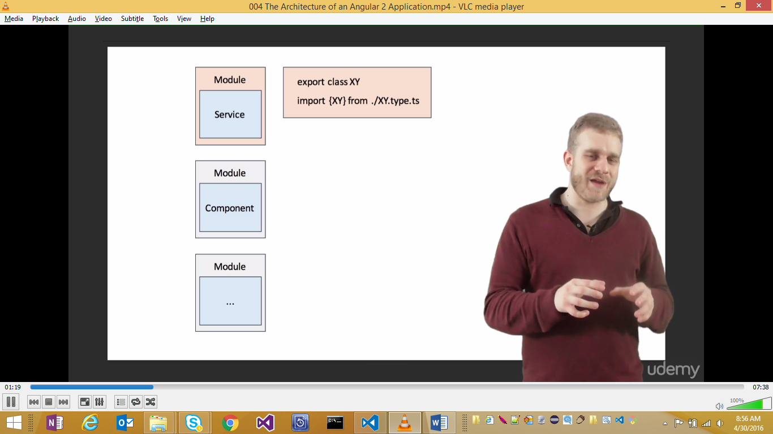 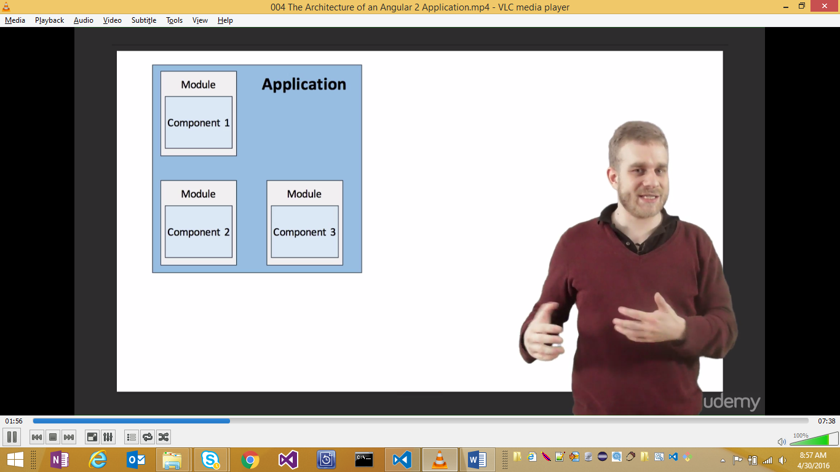

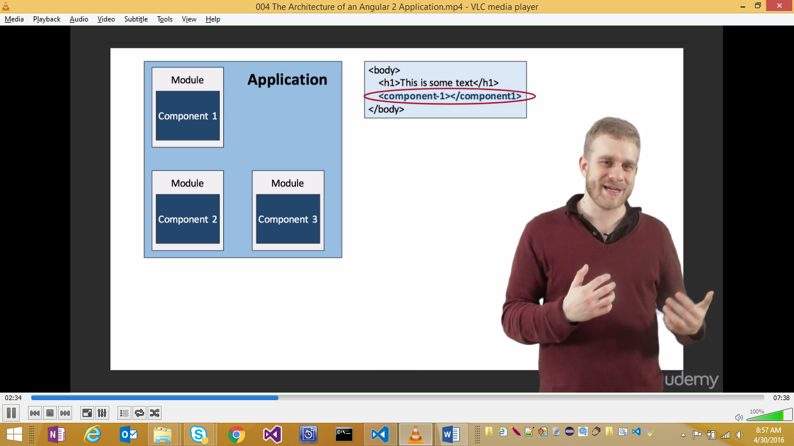

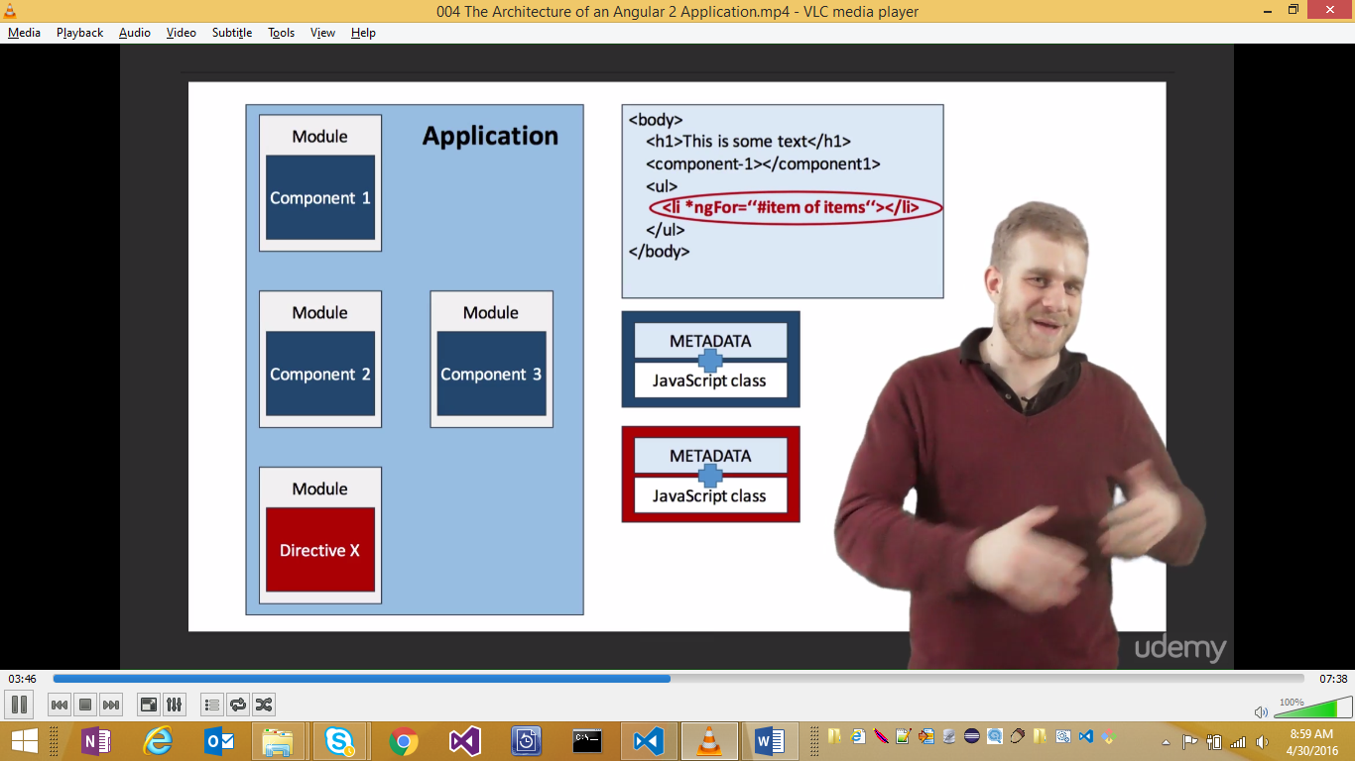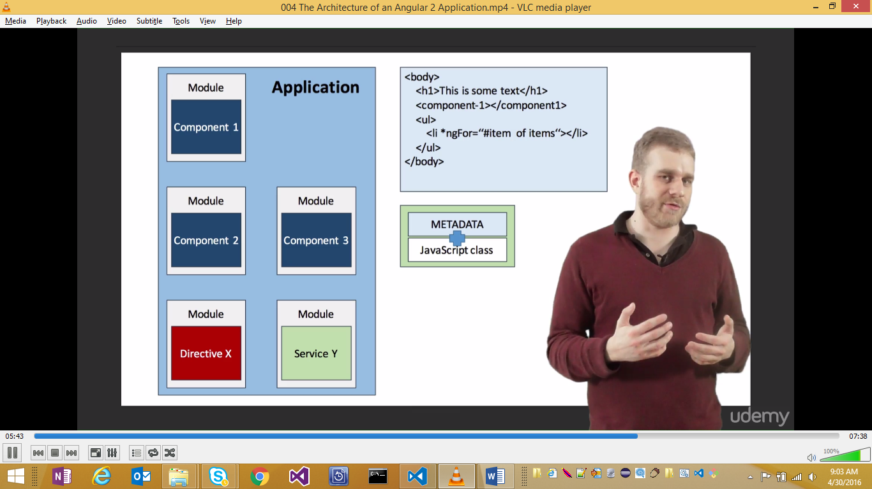

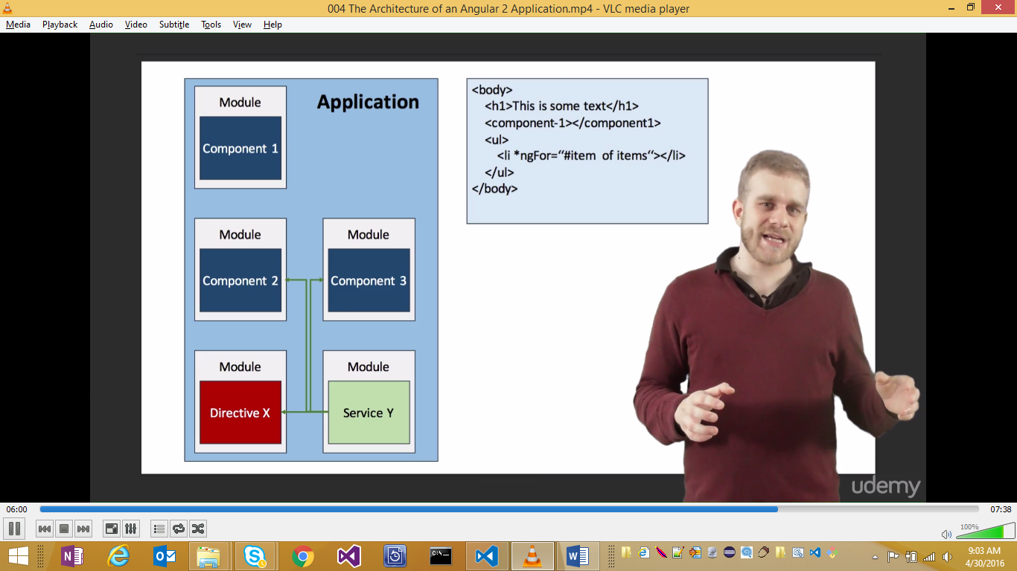

**Using Typescript:**

* Superset to Javascript
* Compiles down to JS but provides capabilities that are not in JAvascript yet e.g. classes and types
* Easier to Debug
* Less error prone
* Similar to other Object Oriented Language
* Angular2 team chose it because of high modularity supported by TS. Also, ease of use of decorators to attach metadata to a class and strong typing
* You can write Angular2 in Javascript or Dart, its probably more convenient and easier to use Typescript a better support is available, most of the documentation is written for TS and even Angular team is using TS.

**Setting up the Environment**

* NodeJS (to use NPM)
  + After installation, update: npn install npm –g
  + npm –v to check the installed version
* Typescript via npm 🡪 npm install typescript
* TypeScript compiler

Setting workspace:

**sage**

Follow the following steps and you're good to go! Important: Typescript and npm has to be installed on your machine!

1: Clone repo

git clone https://github.com/mschwarzmueller/angular-2-beta-boilerplate.git

2: Install packages

npm install

3: Start server (includes auto refreshing) and gulp watcher

npm start

**Overview of the directory Structure:**

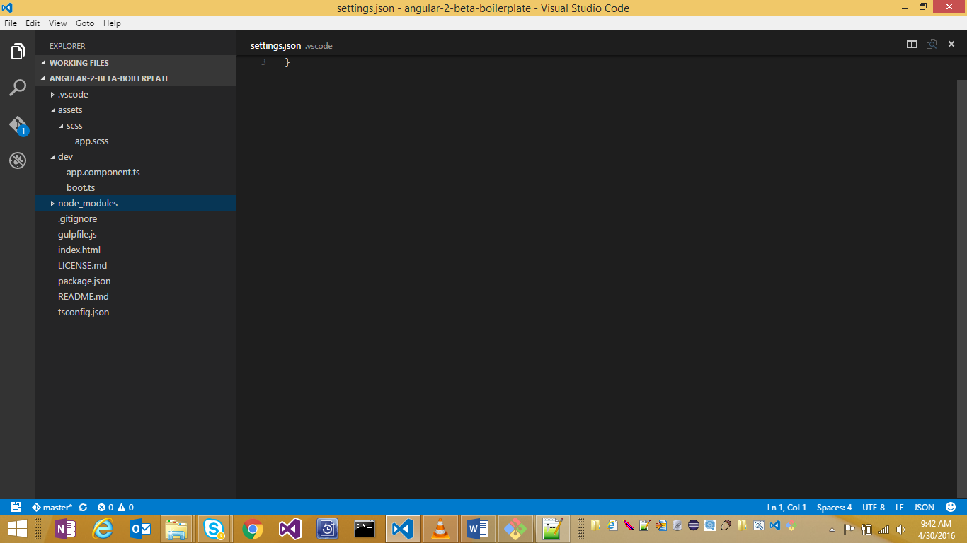

* App – Contains compiled JS
* Assets – Contains scss that gets compiled to Css
* Dev – TS files
* Src – compiled css files
* Typings – some info for typescript

**Import Dependencies:**

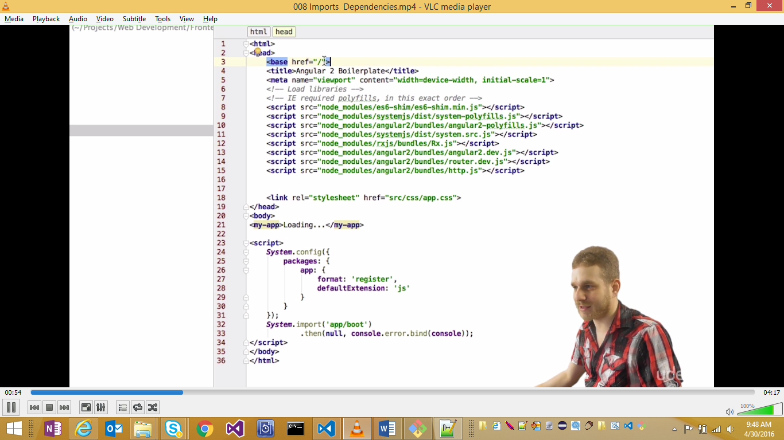

Base href 🡪 sets the base directory

Polyfils 🡪 used by IE

Angular2, router and http 🡪 are for Angular core

Rx.js import 🡪 Allows usage of Observables

**Components:**

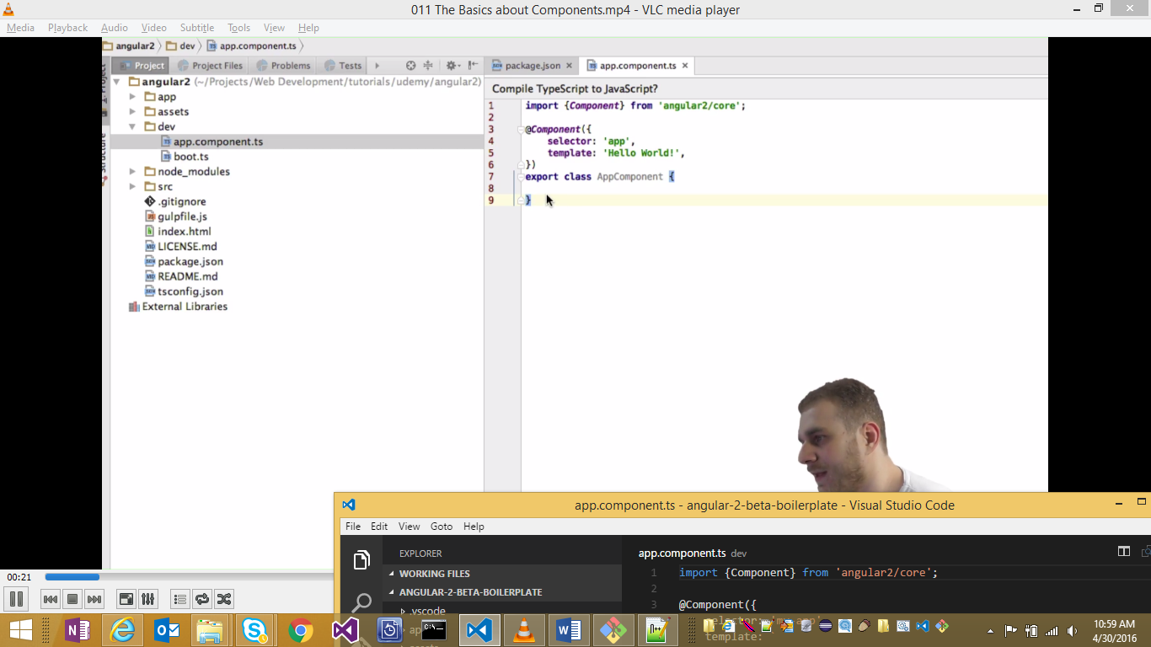

1. Import {Component}
2. Export class
3. Add @component decorator
   1. Provide selector – This component can be used in HTML file by using tag named as selector. This is not a default html rather a custom angular tag. Angular scans and replaces with the template
   2. Provide template
4. Import new component into AppComponent – root
5. Add as directive metadata
6. Use it as a tag in template in AppComponent

Key things to remember:

1. There is only 1 HTML – say index.html for SPA
2. In this, the root component is used in a nested way for the application

<my-app>Loading...</my-app>

1. System.import specifies bootstrap file where the root component is imported and bootsrapped

<script>

System.config({

packages: {

app: {

format: 'register',

defaultExtension: 'js'

}

}

});

System.import('app/boot')

.then(null, console.error.bind(console));

</script>

**Manipulating Templates**

# creates a local variable.

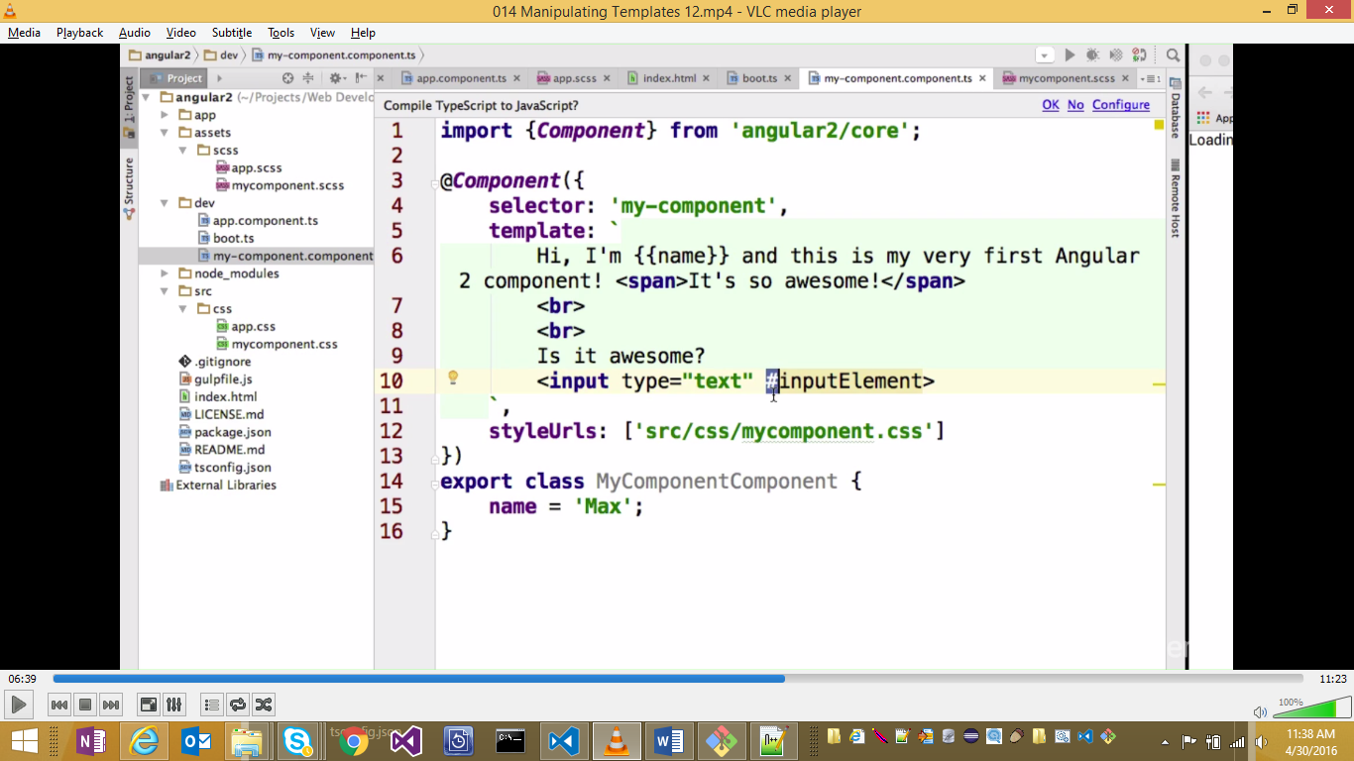

Note that UI updates only when an event occurs.

Note for memory:

[] 🡪 Putting something into element

() 🡪 Listening and getting something out of element

**External Template Component LifeCycle**

OnInit is an interface that needs to be implemented if we want to fire the component at the time component is initialized.

The lifecycle method (e.g. ngOnInit ) will be called if the Component implements OnInit Interface

Classes and Styling:

Option 1: [class.classname]=”boolean expression”

Option 2: [ngClass]=”{classname: Boolean expression}”

Similarly for Styles:

Option 1: [style.property]=”boolean expression”

Option 2: [ngStyle]

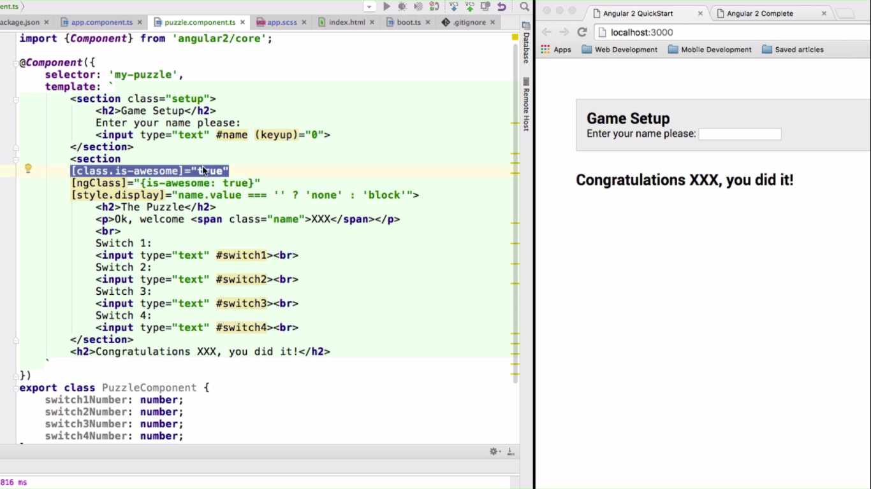

== v/s ===

== Can be used when the types are not equal. Not ===

Chapter 3: Data Binding:

Types of binding:

1. Interpolation : {{}}
2. Property binding:[] 🡪 Something flows into an element
3. Event Binding: () 🡪 Something comes out of the element on a change or event
4. 2-Way data bainding

In Angular2, default flow of data is one direction. That helps with debug etc

Interpolation: <br>Example 5: <input type="text" value="{{name}}" class="{{'red'}}">

Property Binding: <br>Example 1: <input type="text" [value]="name" class="{{'red'}}">

Note there is a difference between “value” of two approaches. In first one its an attribute of html element where as in second one, its an angular construct.

Note that property binding can also work with directives:

<br>Example 2: <input type="text" [value]="name" [ngClass]="’red’">

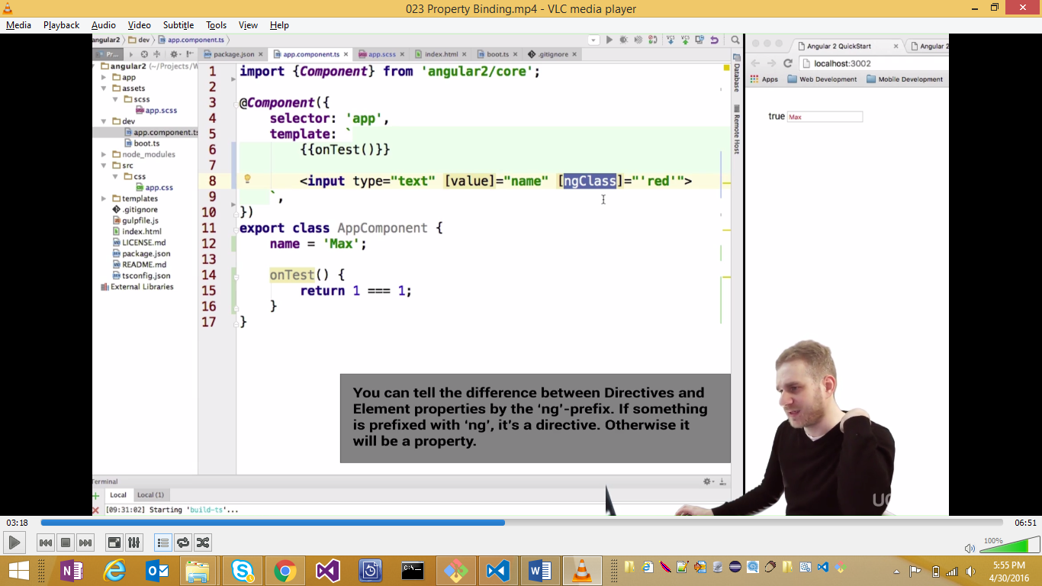



<br>Example 1: <input type="text" [value]="name" class="{{'red'}}">

<br>Example 2: <input type="text" [value]="name" [ngClass]="'red'">

<br>Example 3: <input type="text" [value]="name" [ngClass]="{red:true}">

**Binding properties with other components**

**EVENT Binding**

Both property binding and interpolation change something into our element. However Event Binding causes or raises the event that leads to change.

This is where we react to changes in our DOM

**Two-way Binding:**

It’s a combination of property and event binding: [()]

**Using Property Binding for Custom components**

**App.component**

import {Component} from 'angular2/core';

import {PropertyBindingComponent} from './property-binding.Component';

@Component({

selector: 'my-app',

template: `

<section class="parent">

<h1> This is a parent Component</h1>

<h4> Please enter your name </h4>

<input type="text" [(ngModel)]="name" >

<br>

Name: {{name}}

<br>

<section class="child">

<my-property-binding [myName]="name" [myAge]="30"></my-property-binding>

</section>

</section>

`,

directives:[PropertyBindingComponent]

})

export class AppComponent {

name: String;

}

PropertyBindingComponent

import {Component,Input} from 'angular2/core';

@Component({

selector:'my-property-binding',

template:`

<h2> This is a Child Component</h2>

<p> Hey my name is {{name}} and I am {{age}} years old !!! </p>

`,

inputs:['name:myName']

})

export class PropertyBindingComponent {

name="deepak";

@Input('myAge') age=20;

}

Till now we have sent data from parent to child. But how to do it from child to parent? From parent I can easily pass the data in form of parameters.

**Event Binding with custom components:**

This can be done through EventEmitter that’s a generic

import {Component} from 'angular2/core';

import {PropertyBindingComponent} from './property-binding.Component';

@Component({

selector: 'my-app',

template: `

<section class="parent">

<h1> This is a parent Component</h1>

<h4> Please enter your name </h4>

<input type="text" [(ngModel)]="name" >

<br>

Name: {{name}}

<br>

<section class="child">

<my-property-binding [myName]="name" [myAge]="30" (hobbiesChanged)="hobbies = $event"></my-property-binding>

</section>

<p> My hobbies are {{hobbies}}</p>

</section>

`,

directives:[PropertyBindingComponent]

})

export class AppComponent {

name: String;

hobbies: String;

}

Property-binding.component.ts

import {Component,Input, Output, EventEmitter} from 'angular2/core';

@Component({

selector:'my-property-binding',

template:`

<h2> This is a Child Component</h2>

<p> Hey my name is {{name}} and I am {{age}} years old !!! </p>

<h4>My hobbies are</h4>

<input type='text' (keyup)="onHobbiesChange(hobbies.value)" #hobbies>

`,

inputs:['name:myName'],

outputs:['hobbiesChanged']

})

export class PropertyBindingComponent {

name="deepak";

@Input('myAge') age=20;

//@Output()

hobbiesChanged = new EventEmitter<String> ();

onHobbiesChange(hobbies:String) {

this.hobbiesChanged.emit(hobbies);

}

}

Summary of Data Binding:

appComponent

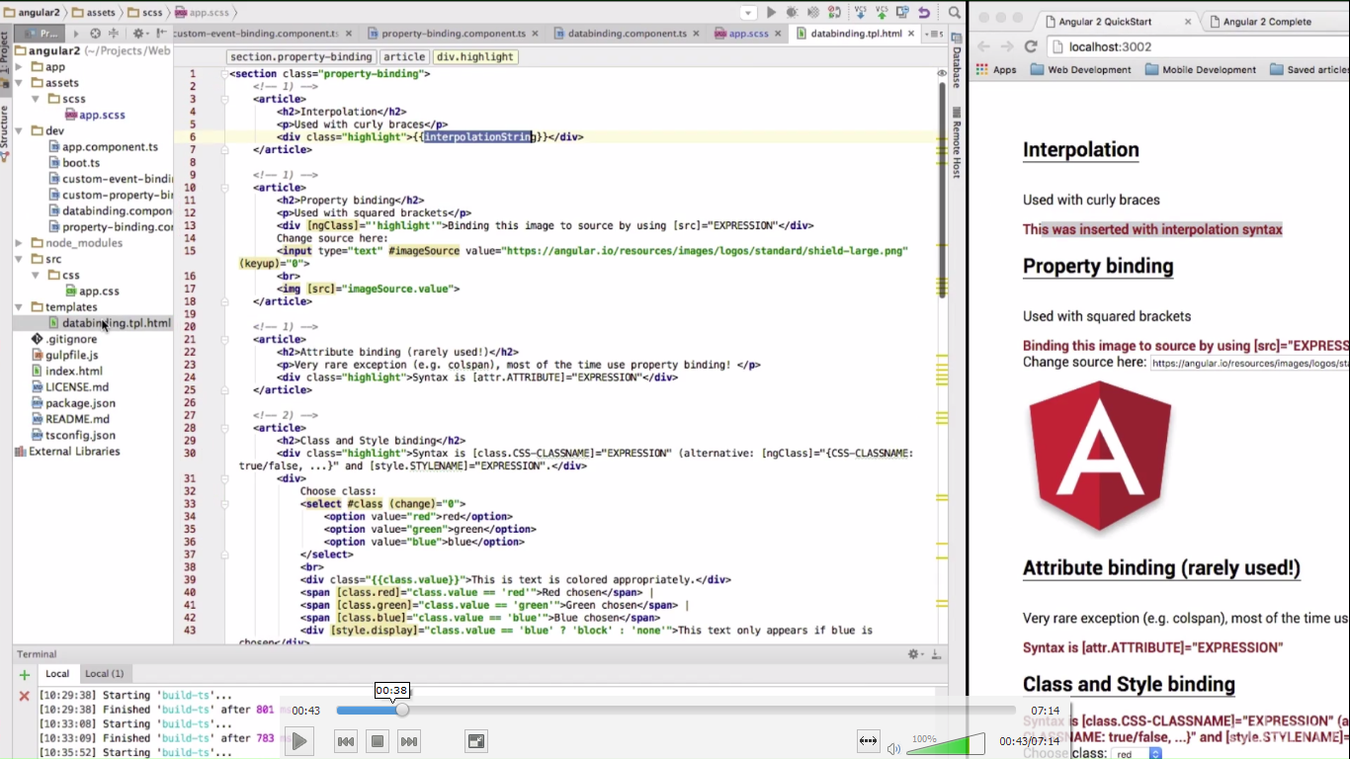

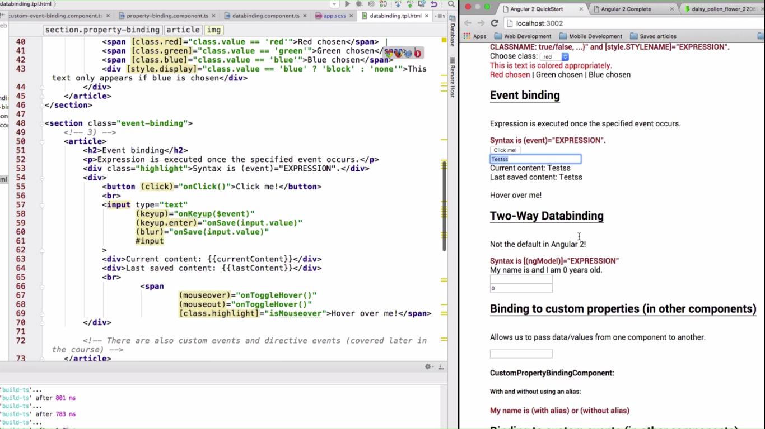

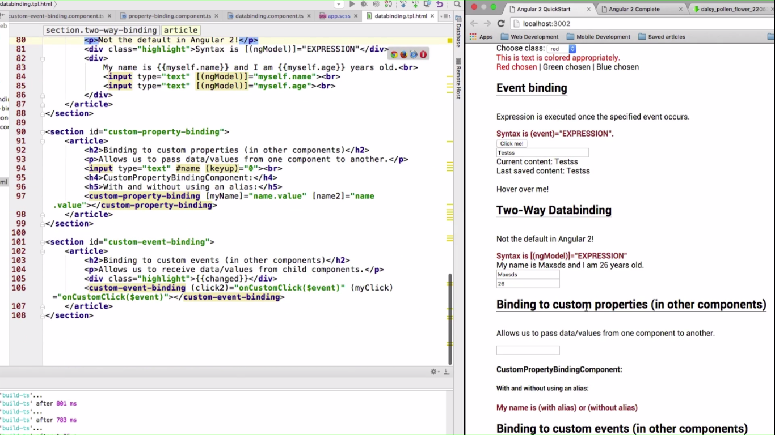

Data binding component

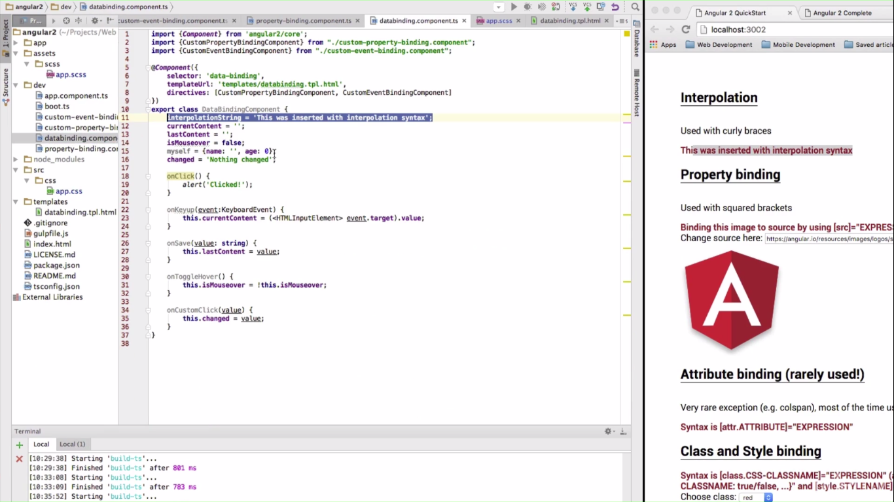

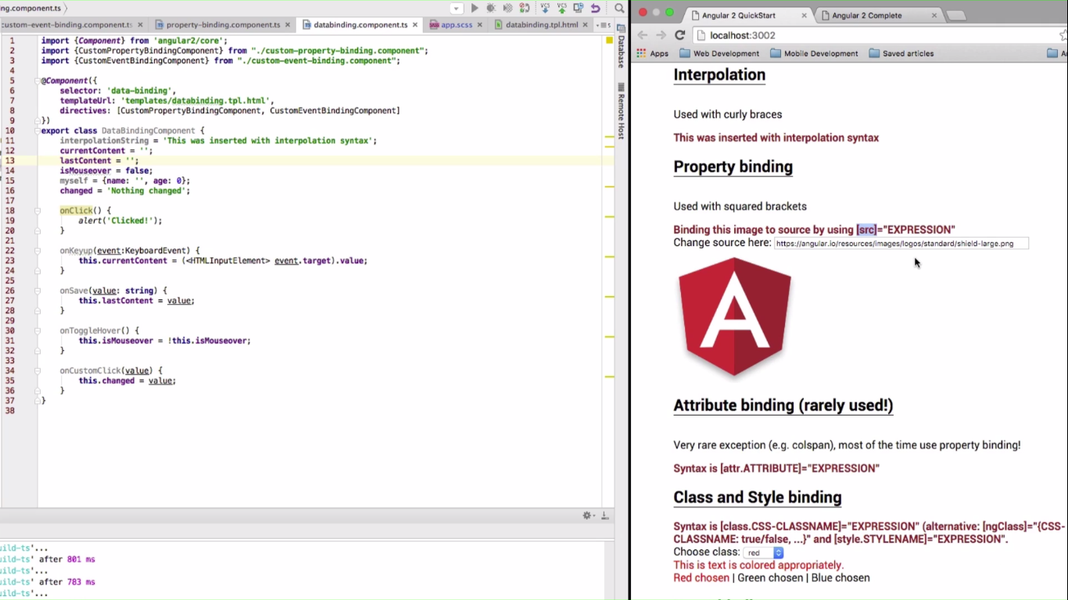



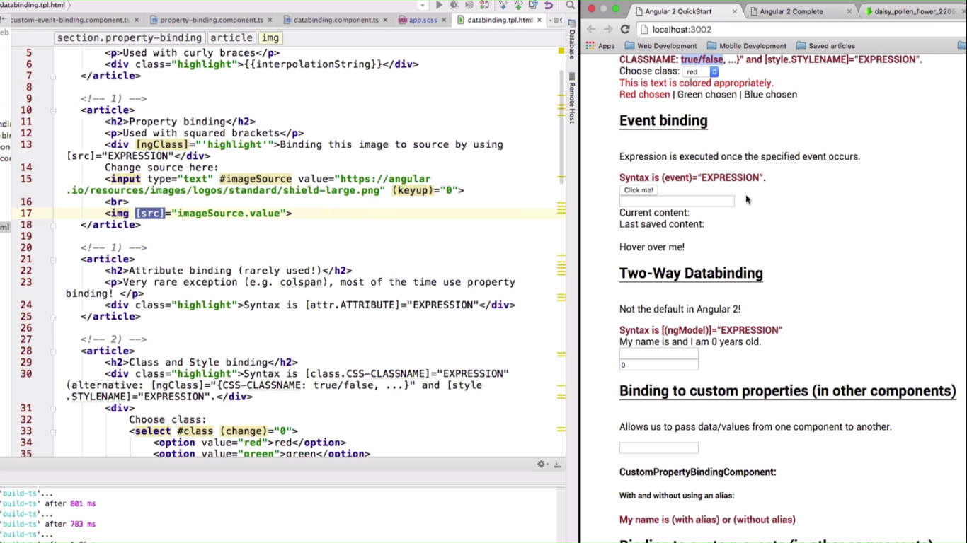

**Project 2:**

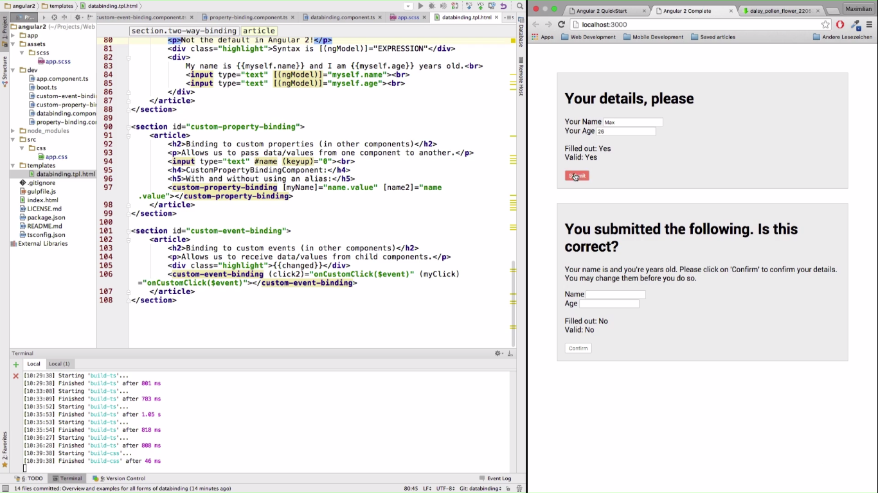

**SECTION 4: Directives:**

* Types of Directives:
  + Attribute Directives: [ngStyle]. They look like property of the html elements bound via property binding
  + Structural directive: Starts with * e.g. *ngFor. They change not just the html element they are attached (similar to attribute) to but also the document.
* Brackets ARE NEEDED Only when we are doing databinding.
* Because of component based approach, very few directives are really needed (much lesser than angular 1).

**Creating Attribute Directives:**

Note that when specifying the name of selector for directive, it is included in []. Don’t confuse this with attribute binding.

* To get the reference to the html element, we use the constructor that utilizes angular2’s dependency injection
* ElementRef can be used to get the reference to the underlying HTML element for which the directive is being invoked.
* onInit is the interface or lifecycle hook that needs to be used to invoke the constructor at the time the directive is initialized.
* SHORTCUT:

private _elRef: ElementRef;

Constructor (elRef:ElementRef) {

this._elRef=elRef;

}

This is same as following:

Constructor (_elRef:ElementRef) {}